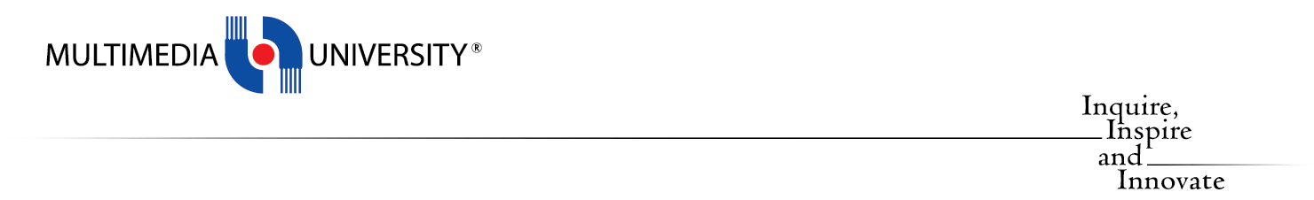

FACULTY COMPUTING AND INFORMATIC

CPP 4213

DATA STRUCTURES AND ALGORYTHMS

Project Report

The Paddock Club

October/November 2025 (Term 2530)

BY:

NO. | STUDENT NAME | STUDENT ID
1. | Adam bin Anwar | 243DC245L4

TO

LECTURER NAME | Ruzanna Abdullah

MULTIMEDIA UNIVERSITY

Table Of Contents
1.0 Introduction.…………………………………………………………………………...... 3
- Project Overview....………………………………………………………………....... 3
- Objective…………………………………………………………………................... 3
- Scope and Targe User………………………………………………………………... 3
2.0 Data Structures………………………………………………………………….............. 4
- 2.1 Linked Lists (Inventory & Customers)…………………………………………... 4
- 2.2 Circular Queue (Wash Bay).…………………………………………................... 5
- 2.3 Linked Stack (Activity Logs).…………………………………………................. 6
- 2.4 Hash Table (Fast Lookup)....................…………………………………………... 7
3.0 Algorithms…………………………………………………………………...................... 8
- 3.1 Merge Sort (Complex Sorting).…………………………………………............... 8
- 3.2 Bubble Sort (Simple Sorting)...............…………………………………………... 8
- 3.3 Binary Search (Search Logic)..............…………………………………………... 9
4.0 System Features and Output………………………………………………….............. 10
- 4.1 Fleet Management (Read/Display).…………………………………………....... 10
- 4.2 Rental Process (Update).....................…………………………………………... 11
- 4.3 Return & Maintenance (Queue Enqueue)..……………………………………... 13
- 4.4 Admin Console (Create/Delete).........…………………………………………... 14
- 4.5 File I/O & Persistence............................………………………………………... 15
5.0 Conclusion.....................................................…………………………………………... 16
6.0 References…………………………………………........................................................ 17

Introduction

Project Overview
"The Paddock Club" is a specialized console based management system developed for a high-end car rental business. Unlike standard rental systems, this project caters to a niche market of exotic and performance vehicles, requiring specific logic for high-horsepower restrictions, maintenance cycles, and dynamic inventory management.
The system is built using C++ and demonstrates the practical application of advanced data structures including Linked Lists, Circular Queues, Stacks, and Hash Tables to solve real world business problems efficiently. It features a persistent database system (CSV) to ensure data integrity across multiple sessions.

Objective
The primary objective of the project are:
- To implement core Data Structures (Linked List, Stacks, Queues and Hash Tables) in practical business scenario.
- To implement efficient Algorithms (Merge Sort, Binary Search) to manage data retrieval and organization.
- To provide a seamless CRUD (Create, Read, Update, Delete) experience for administrators managing the fleet.

Scope and Target User
The system is designed for rental administrators. Its scope includes:
- Fleet Management: Dynamic addition and removal of vehicles.
- Rental Processing: Customer booking with age verification and stock tracking.
- Maintenance: A "Wash Bay" system that queues returned cars before they can be rented again.
- Analytics: Tracking revenue and generating audit logs for all user actions.

2.0 Data Structures
The system architecture relies on four distinct data structures, each chosen to optimize a specific aspect of the application.

2.1 Linked Lists (Inventory & Customers)
Theory: A Linked List is a linear data structure where elements are not stored in contiguous memory locations. Instead, each element (node) points to the next.

Implementation A: Fleet Inventory, we selected a Singly Linked List for the main showroom inventory because the fleet size is dynamic. In an real world scenario, cars are frequently bought (added) and sold (deleted). A linked list allows for O(1) insertion and deletion at the head, preventing the need to resize arrays constantly.

Figure 2.1.1: Node Structure Implementation First, we defined the Node structure, which acts as the building block. Each node holds a pointer to a Car object and a pointer to the next node.

Implementation B: Customer Records, a second linked list tracks active rentals. As customers rent cars, new nodes are linked to the head of the list. This provides a dynamic record of all active bookings without pre-allocating memory for a maximum number of customers.

Figure 2.1.2: Add Function Implementation The add function handles the logic of inserting these nodes. We traverse to the end of the list to ensure new cars are added to the bottom of the showroom table, maintaining the order of entry.
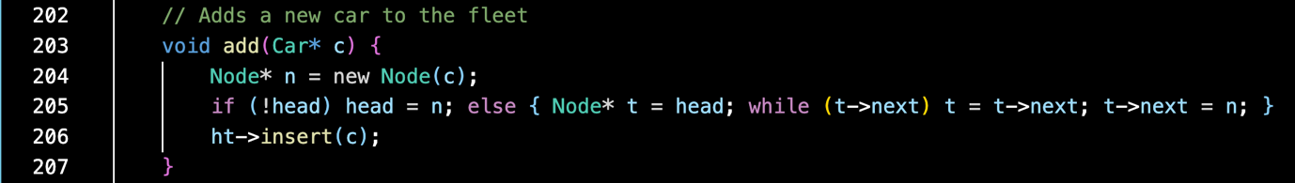

2.2 Circular Queue (Wash Bay)

Theory: A Queue follows the First-In, First-Out (FIFO) principle. We implemented this as a Circular Array to simulate the "Wash Bay." When a car is returned, it must be washed before it is available again.

Implementation: The ServiceQueue class uses a fixed array of size 10. Variables front and rear track the queue's state. Modulo arithmetic (%10) is used to wrap the indices around the array. This ensures that we can reuse array positions continuously without shifting elements, providing O(1) complexity for enqueue and dequeue operations.

Figure 2.2.1: Queue Class Properties We defined a fixed integer array and tracking variables for the front and rear of the queue.
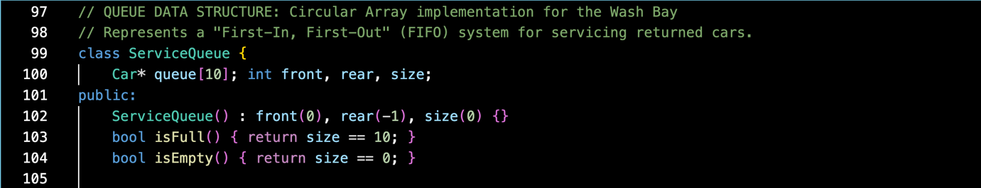

Figure 2.2.2: Enqueue Logic The enqueue function adds a car to the wash bay. It uses the modulo operator to "wrap around" to index 0 if the array reaches index 9.
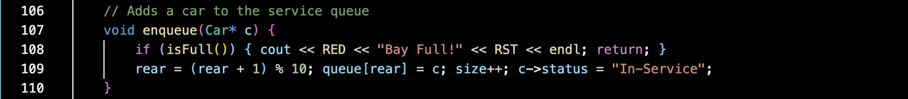

2.3 Linked Stack (Activity Logs)

Theory: A Stack follows the Last-In, First-Out (LIFO) principle. This is ideal for activity logs (Audit Trails) because administrators typically want to see the most recent actions first. We used a Linked List implementation for the stack to avoid the fixed-size limitations of array-based stacks.

Figure 2.3.1: Stack Node Structure Similar to the main inventory, the logs require their own node structure to hold the string data.

Figure 2.3.2: Push Operation The push operation creates a new node and points it to the current top.
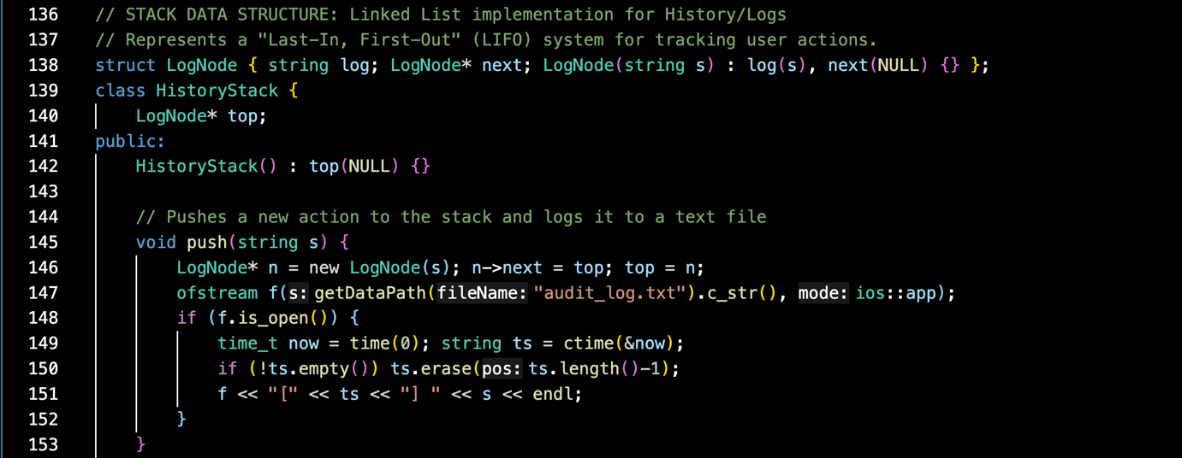

2.4 Hash Table (Fast Lookup)

Theory: Searching through a Linked List is O(n), which can be slow for large inventories. A Hash Table reduces average search time to O(1) by mapping keys (Car IDs) to specific indices in an array.

Implementation: We used a custom hash function that sums the ASCII values of the Car ID characters and applies modulo 50. Collision resolution is handled via Chaining (each bucket contains a linked list of nodes).

Figure 2.4.1: Hash Function This function converts the string ID (e.g., "GTR35") into an integer index for the array.
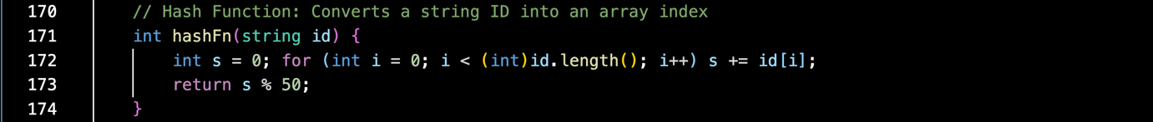

Figure 2.4.2: Search Logic The search function jumps directly to the calculated index, bypassing the need to scan the entire list.
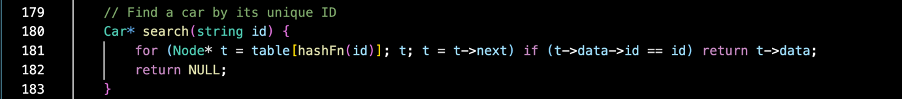

3.0 Algorithms

3.1 Merge Sort (Complex Sorting)

Theory: Merge Sort is a divide-and-conquer algorithm with a time complexity of O( n log n). It is preferred over Bubble Sort for large datasets because of its superior worst-case performance.

Application: We implemented Merge Sort to allow users to sort the car fleet by Price (Low-High), Horsepower (High-Low), or Year.

Figure 3.1.1: Merge Logic This function takes two sorted sub-lists (a and b) and merges them into a single sorted list based on the chosen mode.
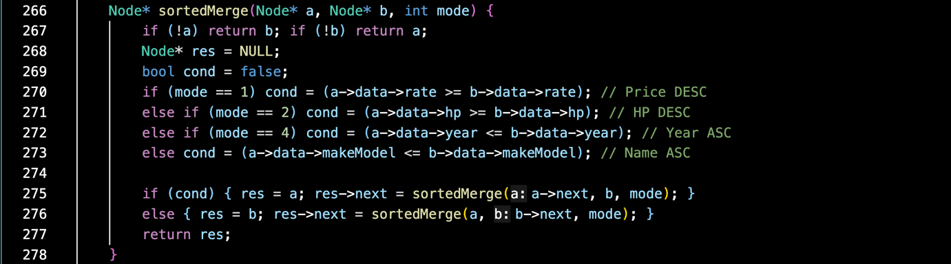

3.2 Bubble Sort (Simple Sorting)

Theory: Bubble Sort is a simple comparison-based algorithm with O(n^2) complexity.
Application: We utilized Bubble Sort specifically for the sortByBrand() function. This runs automatically when the database is loaded to ensure the fleet is alphabetized by default.
Figure 3.2.1: Bubble Sort Implementation The nested loops compare adjacent nodes and swap their data if they are out of order.
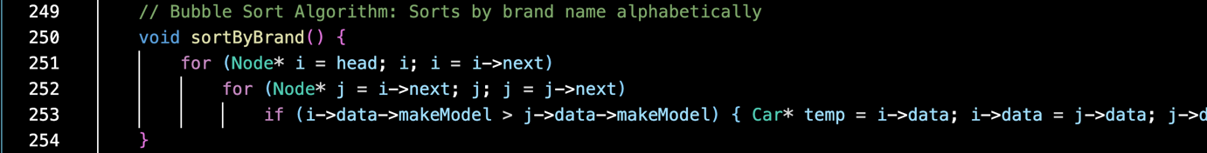

3.3 Binary Search (Search Logic)

Theory: Binary Search is an efficient search algorithm that finds an element in a sorted list by repeatedly dividing the search interval in half. It has a time complexity of O(log n).

Application: Binary Search is used when searching for cars by Year. Since Binary Search requires a sorted array, our implementation first performs a Merge Sort on the list by year, then converts the list to a temporary array.

Figure 3.3.1: Binary Search Implementation
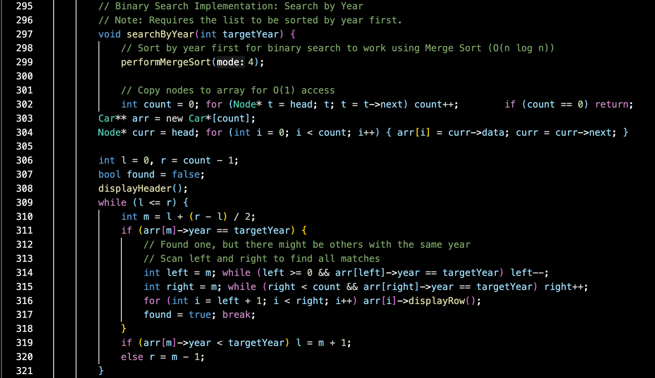

4.0 System Features and Output

4.1 Fleet Management (Read/Display)
The main dashboard displays the fleet in a formatted table. We used ANSI escape codes (\033[32m for Green, etc.) to visually distinguish available cars from those that are out of stock.

Figure 4.1.1: Main System Dashboard displaying the full vehicle inventory with ANSI color-coded status indicators.
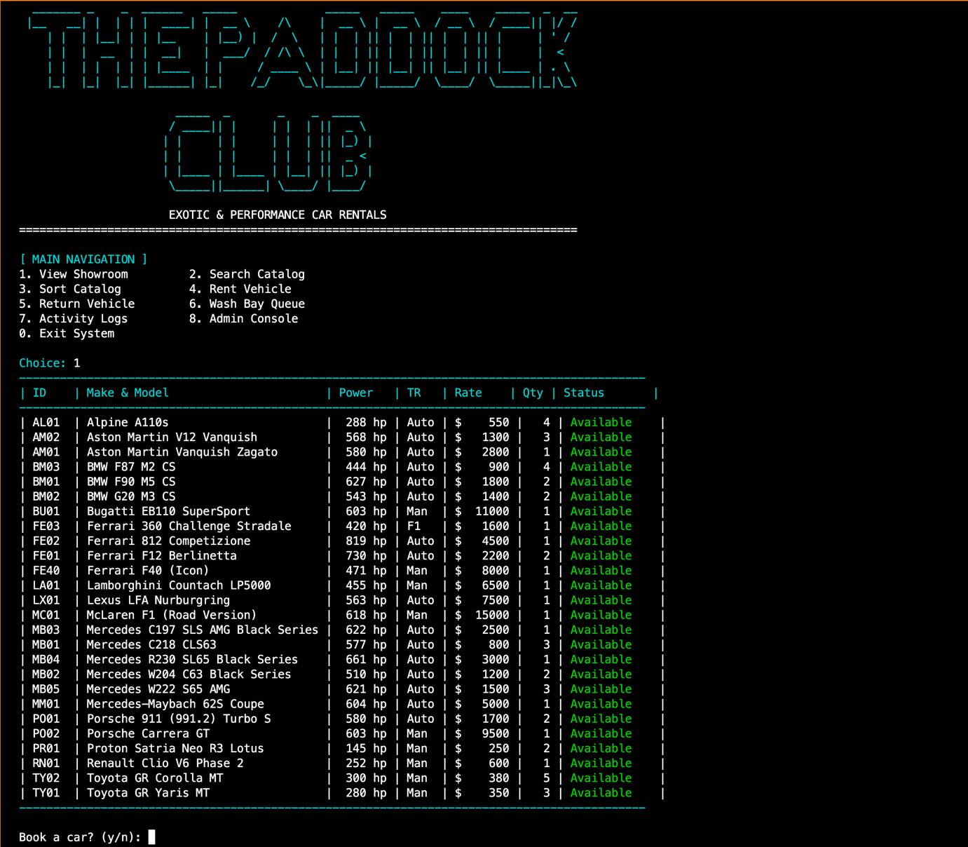

4.2 Rental Process (Update)

When a user rents a car:
- The system checks availability via the Linked List.
- It enforces an age restriction (Driver must be 25+ for >500 HP cars).
- Stock is decremented, and the status is updated to "Rented".
- Revenue is calculated and saved to Revenue_Report.txt.

Figure 4.2.1: Successful rental transaction output showing booking confirmation and total cost calculation.
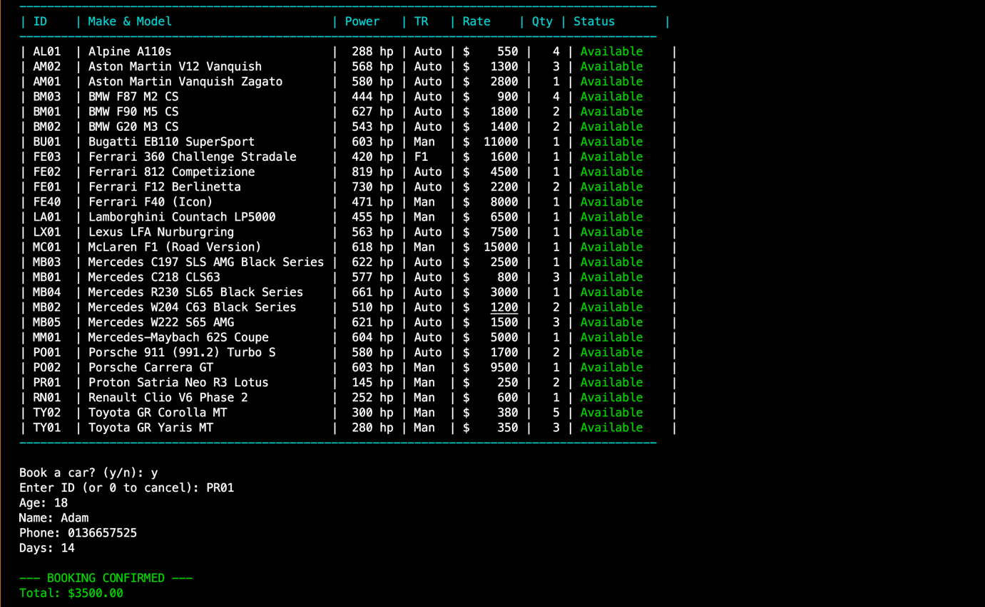

Figure 4.2.2: Security feature demonstrating the Age Verification logic rejecting an underage user for a high-horsepower vehicle.
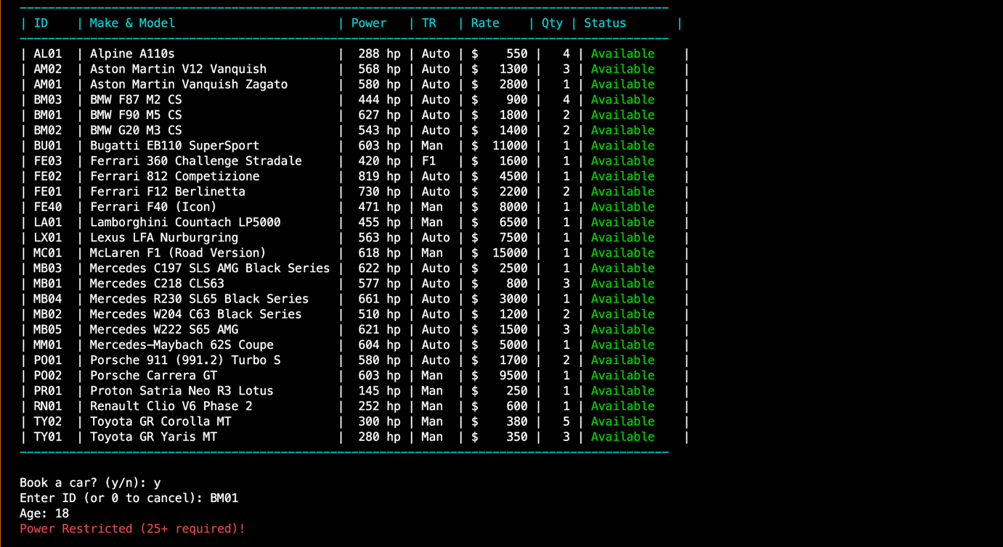

4.3 Return & Maintenance (Queue Enqueue)

Returning a car does not immediately make it available. It is enqueued into the Wash Bay. This prevents dirty cars from being rented immediately.

Figure 4.3.1: Vehicle Return Interface prompting the user for the Car ID to be checked back in.
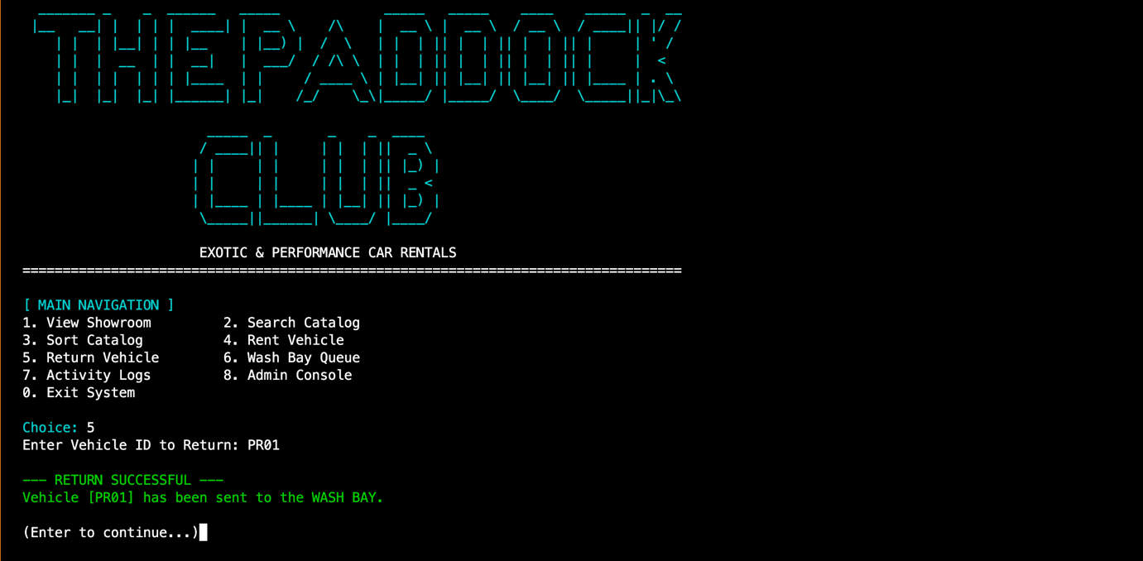

Figure 4.3.2: Wash Bay Queue display demonstrating the Circular Array structure holding returned vehicles.
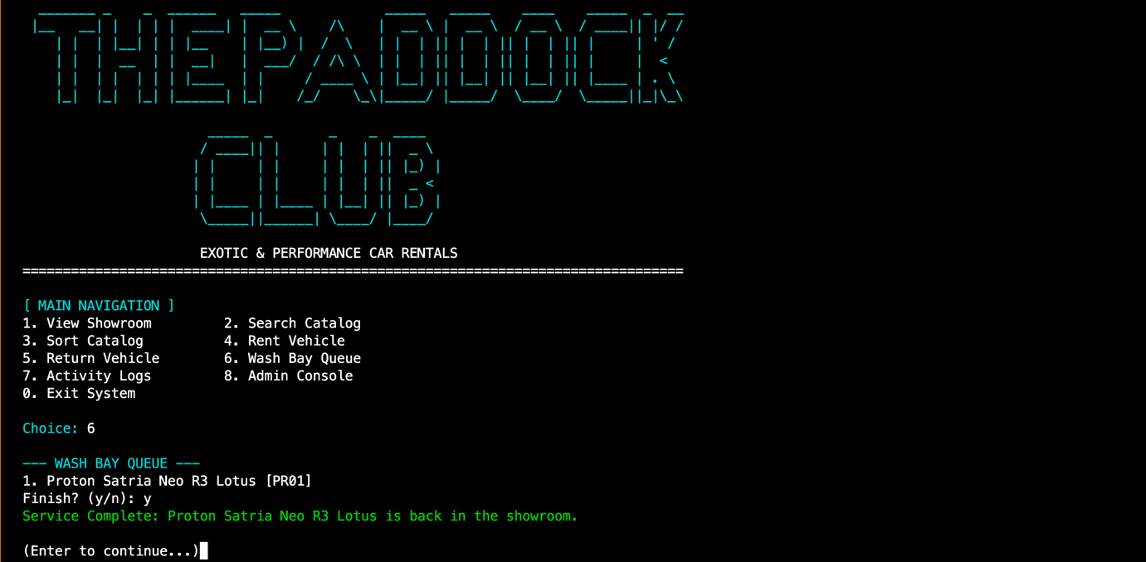

4.4 Admin Console (Create/Delete)

A password-protected admin panel allows for adding new cars or removing old ones. The deletion process verifies that the car is not currently rented or in the wash bay before removing it from the Linked List and Hash Table.

Figure 4.4.1: Secure Admin Console showing the vehicle addition interface and fleet modification options.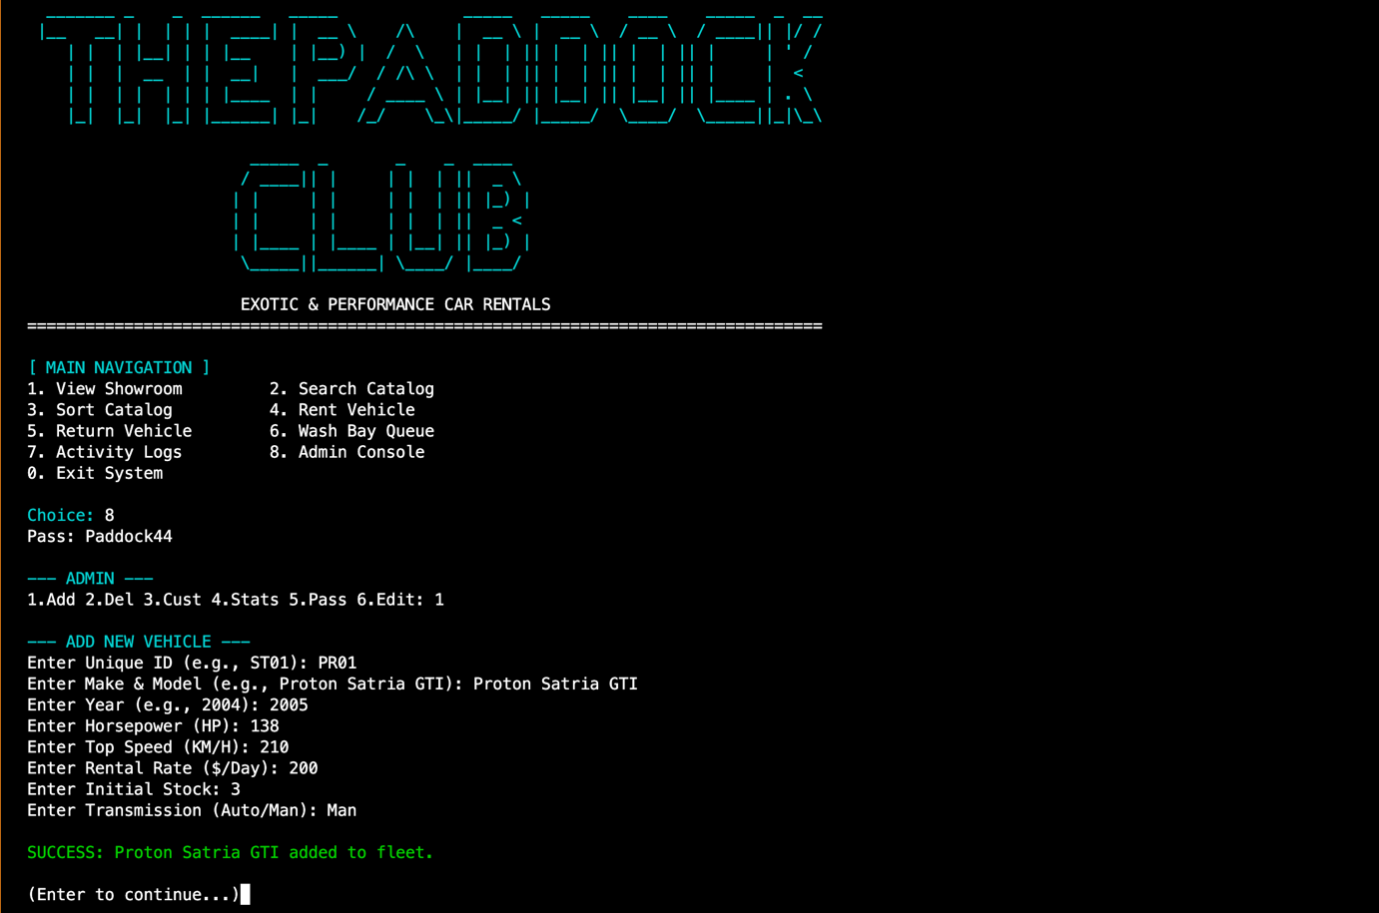

4.5 File I/O & Persistence
To ensure data is not lost when the program closes, we implemented custom file handling using C++ fstream.
- Database: We use db_fleet.csv and db_customers.csv to store data.
- Parsing: We utilized stringstream to parse comma-separated values (CSV) manually, converting strings to integers (stoi) and doubles (stod) where necessary.
Figure 4.5.1: C++ implementation of the loadFromFile function utilizing std::vector for robust CSV parsing and data persistence.
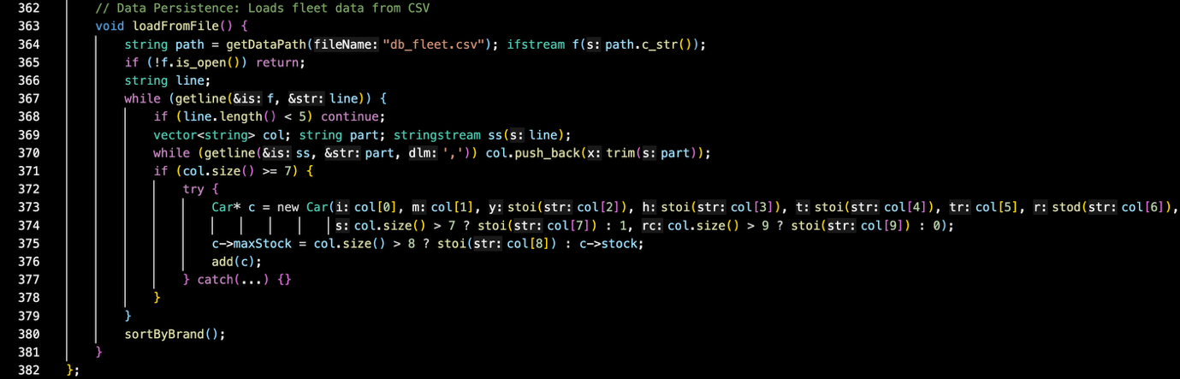

5.0 Conclusion

The Paddock Club project successfully integrates advanced data structures to create a robust car rental management system. By implementing a Hash Table, we achieved O(1) lookup times for inventory management. The use of Merge Sort ensures the system remains performant even as the fleet grows, maintaining O(n log n) sorting efficiency. Finally, the Circular Queue correctly models the real-world constraint of a wash bay service line. The project meets all functional requirements and demonstrates a deep understanding of memory management and algorithm design in C++.

6.0 Refrences
• Multimedia University. (2026). Chapter 1: Introduction to Data Structure and Algorithms [Lecture slides]. Faculty of Computing and Informatics.
• Multimedia University. (2026). Chapter 2: Pointer and pointer variable [Lecture slides]. Faculty of Computing and Informatics.
• Multimedia University. (2026). Chapter 3: Stack and Queue [Lecture slides]. Faculty of Computing and Informatics.
• Multimedia University. (2026). Chapter 4: List and Linked List [Lecture slides]. Faculty of Computing and Informatics.
• Multimedia University. (2026). Chapter 5: Linked Stacks and Queues [Lecture slides]. Faculty of Computing and Informatics.
• Multimedia University. (2026). Chapter 6: Searching [Lecture slides]. Faculty of Computing and Informatics.
• Multimedia University. (2026). Chapter 7: Hashing [Lecture slides]. Faculty of Computing and Informatics.
• Multimedia University. (2026). Chapter 8: Sorting [Lecture slides]. Faculty of Computing and Informatics.
• DevDocs. (2025). std::vector - C++ Vector Library. Retrieved from https://devdocs.io/cpp/container/vector
• DevDocs. (2025). std::fstream - C++ Input/Output Library. Retrieved from https://devdocs.io/cpp/io/basic_fstream
• GeeksforGeeks. (2024). Merge Sort for Linked Lists. Retrieved from https://www.geeksforgeeks.org/merge-sort-for-linked-list/

